Assignment 1: Learning Environment Evaluation Rubric
Alice Sin, Kathryn Richards, Andrew Dunn, and Julia Cheong
ETEC 524: Learning Technologies: Selection, Design, and Application
Dr. Natasha Boskic
February 4, 2024

Scenario
The Hungarian Ministry of Human Capacities (Wikipedia contributors, 2024) has identified the strategic goal of improving enrollment and successful completion of business-oriented programs in Hungarian higher education institutions. Twenty-eight of the 53 accredited HEIs in Hungary (OECD, 2017) offer Business Mathematics courses. Learning Management System (LMS) selection happens at institution level, and three main platforms are presently in use, alongside two student information systems (SIS). Educational technology and LMS use among instructors in Business Mathematics is low, with an LMS being used in only 53% of programs. Furthermore, where an LMS is used, it is mostly to complement traditional pedagogies; the ‘S’ and ‘A’, rather than the ‘M’ and ‘R’ elements of the SAMR Model (Puentedura 2010). Business Mathematics instructors also sometimes make use of specialist mathematics tools, usually outside of the LMS. The Deans of the 28 HEIs are keen to move towards using technology more effectively, in particular for collaborative and project-based learning (i.e., incorporating the ‘M’ and ‘R’ of the SAMR Model). The Deans are looking to unify technology use under a single LMS and have requested a task force be created to help them in this aim.
The current inconsistent and sometimes ad-hoc use of educational technologies is seen as a contributor to low enrollment and poor outcomes. Internationalization, while not directly referenced by the Ministry or Deans in the Terms of Reference for the task force, is an important consideration in Hungarian higher education in general, and in business programs in particular. The number of international students studying in Hungary is growing year-on-year (Statista.com, 2023), and better planning and implementation of appropriate educational technologies will be key to maintaining this trend. The task force is required to research the requirements of an LMS to meet these diverse goals, and to provide a rubric to support the Deans in making the final decision.
Rubric
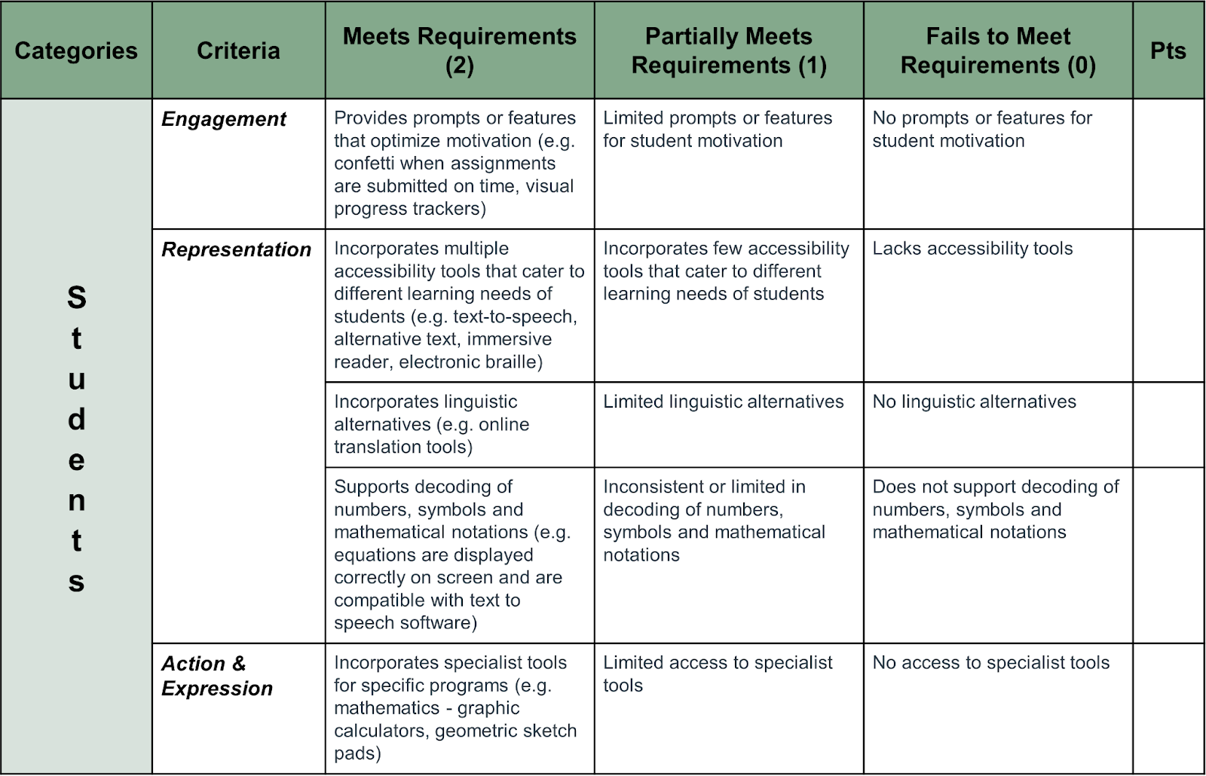

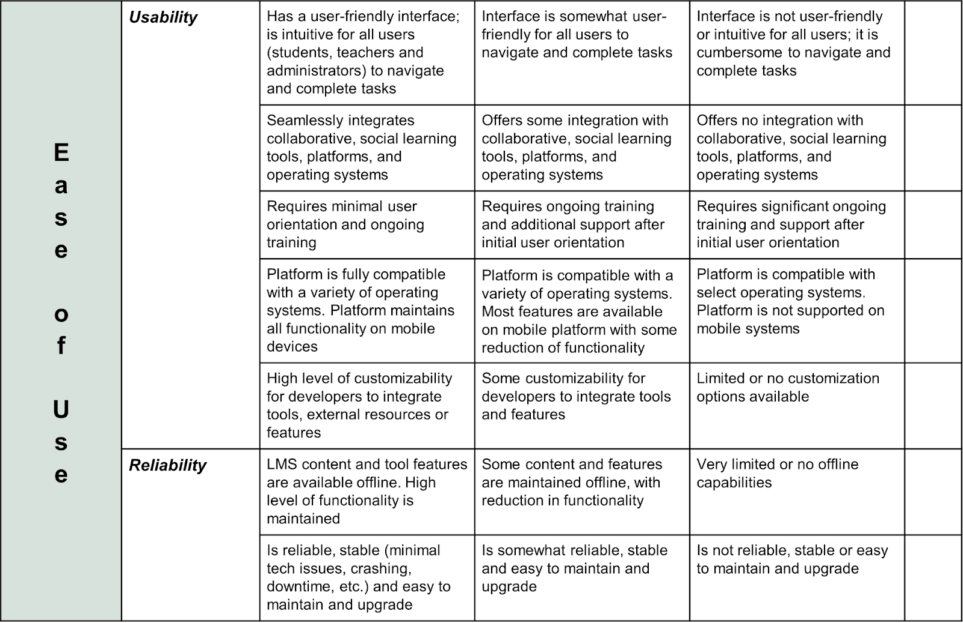

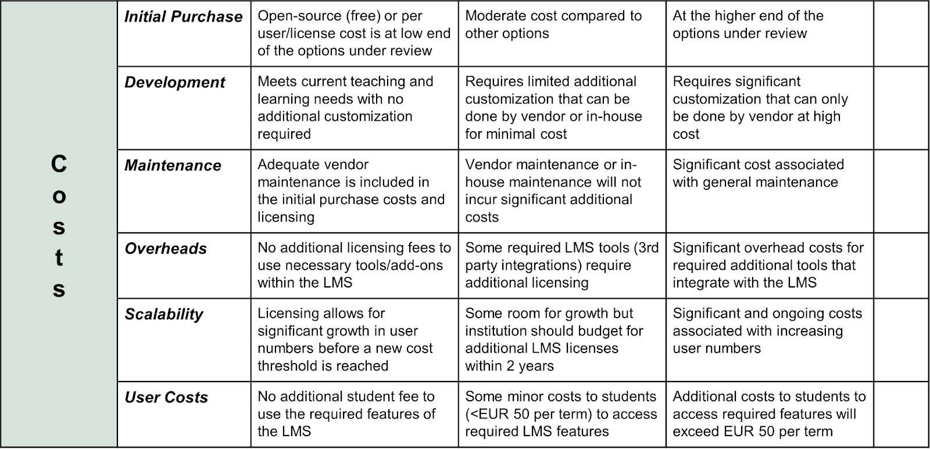

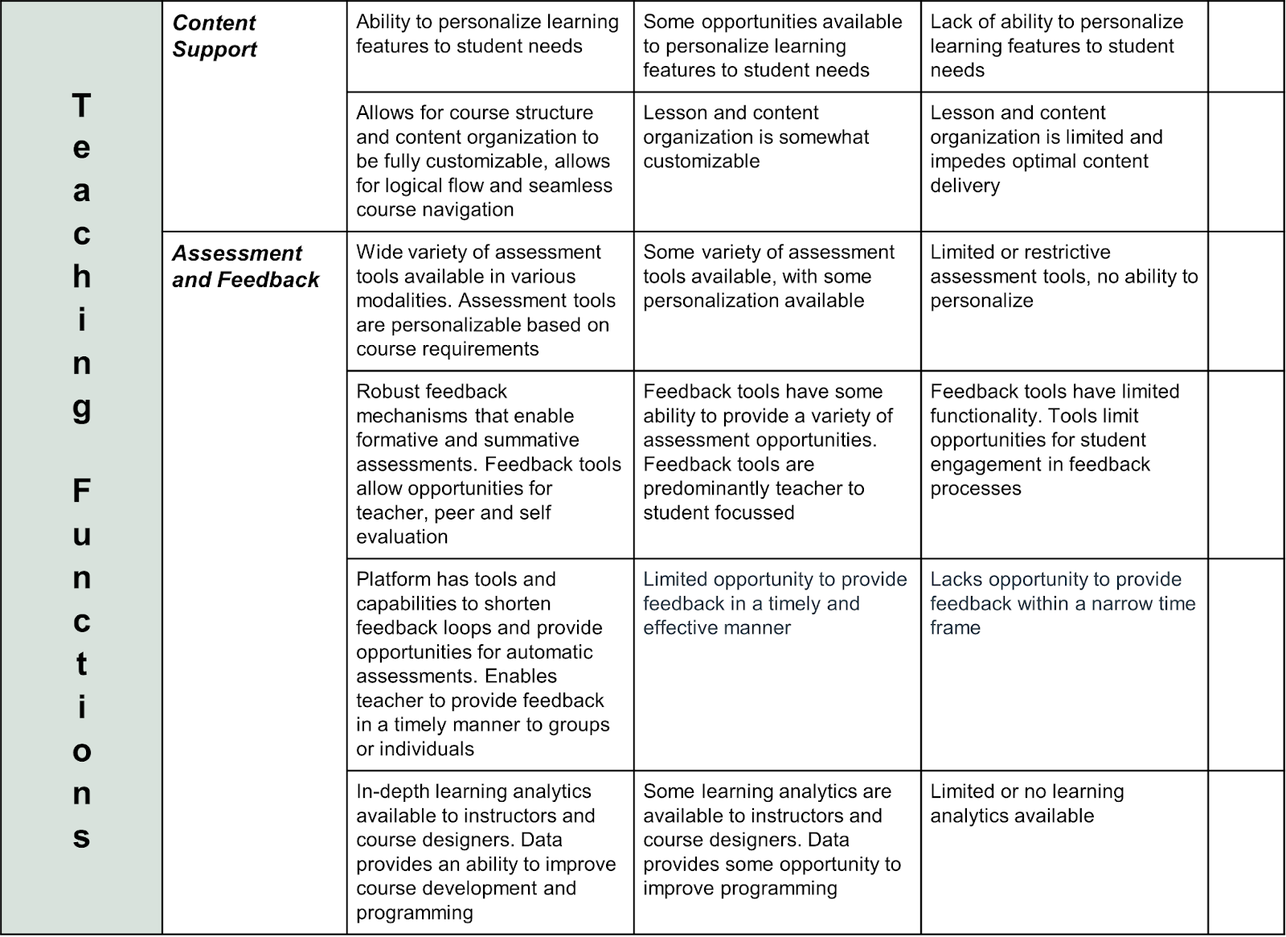

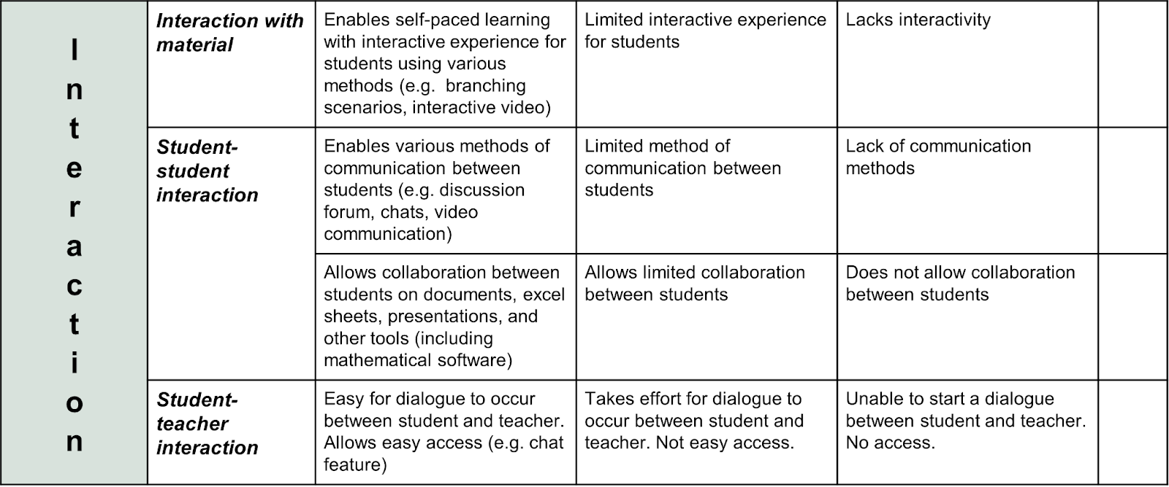
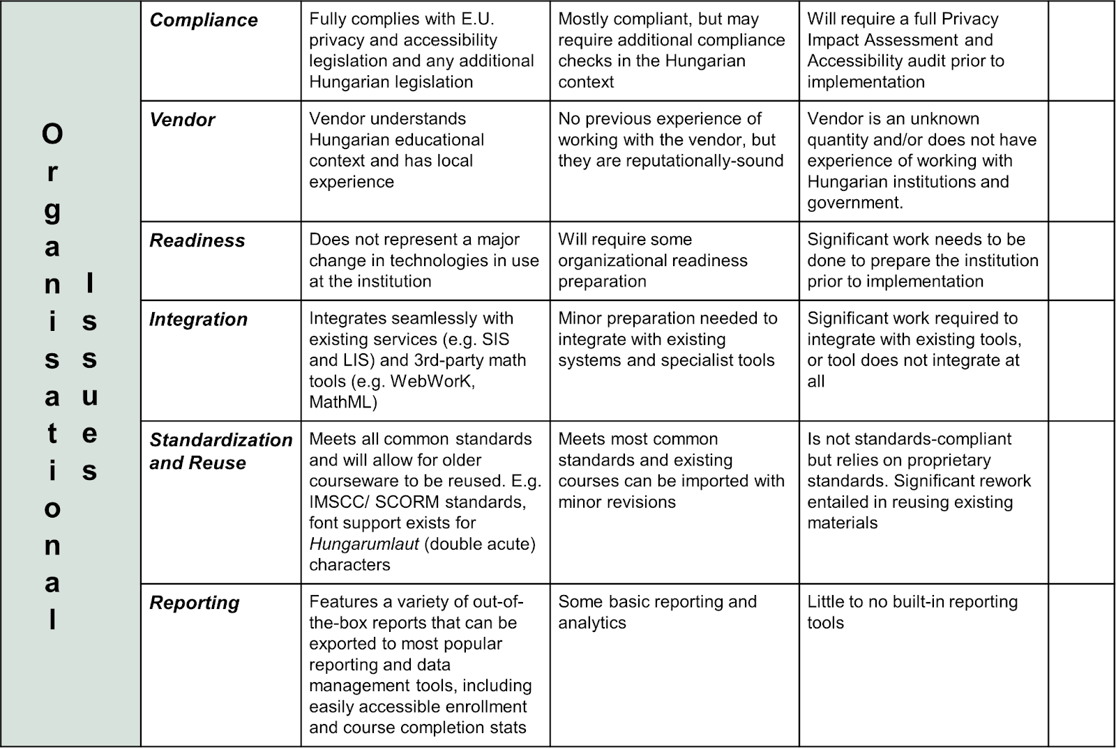
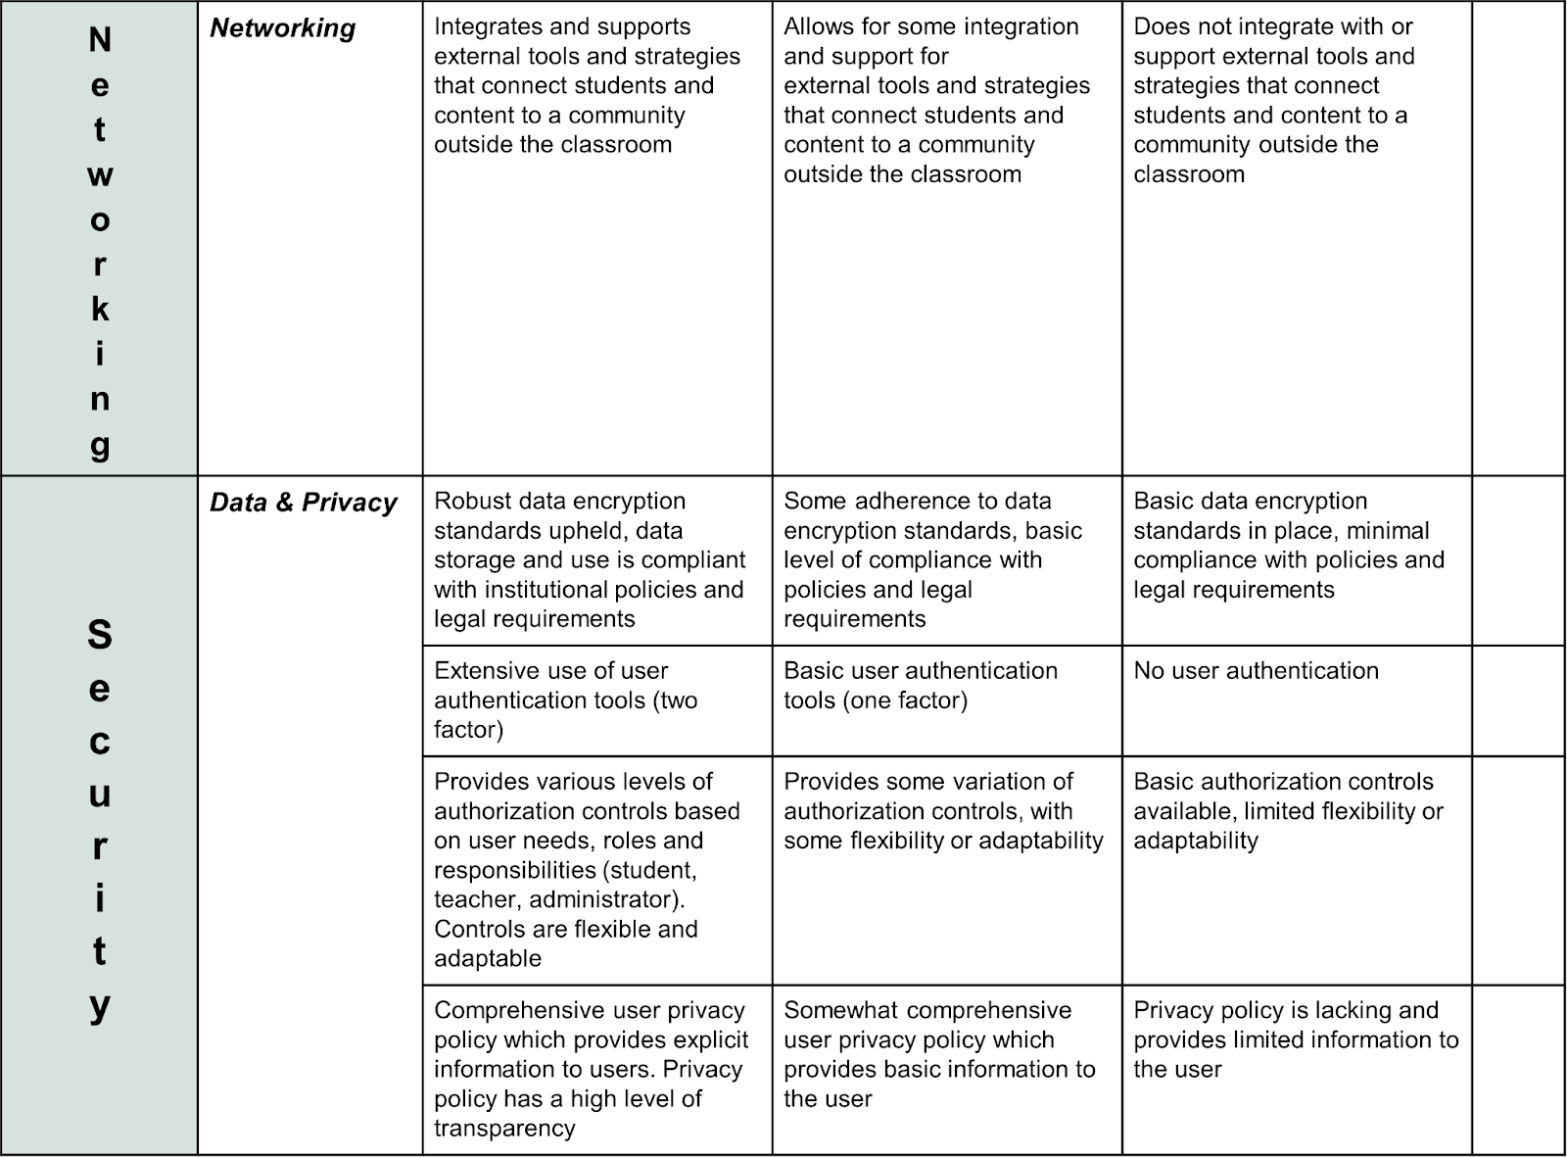

Rationale
We chose to structure our rubric based on Bates’ (2014) SECTIONS framework. Our task was to identify the required criteria for an LMS to meet the largely pedagogical concerns of the Ministry and Deans, and Bates’ framework guided us in designing a rubric that meets these goals. The rubric addresses the questions of underutilization of the LMS by both teachers and students, the heavy reliance on external platforms, and focuses on streamlining the learning experience. Given the particular needs of business-oriented programs that include mathematics courses, we wanted to make sure that access to specialist tools was included as a criterion. We referenced the Universal Design for Learning (UDL) (CAST, 2008) framework for the Students category to ensure that all learners will have equitable access and participation opportunities. To promote moving away from a simple ‘e-text and quiz model’ and towards a collaborative and project learning environment, we emphasized the need for tools to enable students to work together online. As the Deans are looking to unify the current program offerings, our rubric includes several criteria related to flexible course designs, the level of compatibility for various platforms and tools, as well as opportunities to customize the tools available. Another directive was the need for enhanced student success rates. Considering this, we included several metrics related to student engagement, personalization of learning, and enhanced feedback and assessment tools that would provide students with a variety of feedback. Studies have shown that providing various forms of feedback has positive impacts on student learning outcomes (Henderson et al., 2019). We also recognized the importance of the LMS as a vehicle for networking, especially in a business program. We addressed not only the interactivity within the course but also being able to network outside of the classroom as one of the criteria under the Network section. In conclusion, our rubric was designed to address the multifaceted needs of the scenario, with a focus on unifying the current technology, enhancing program success and improving learner outcomes.
References
CAST (2018). Universal design for learning guidelines (version 2.2). Wakefield, MA: Author
Henderson, M., Ajjawi, R., Boud, D., & Molloy, E. (2019). Identifying feedback that has impact. In M. Henderson, R. Ajjawi, D. Boud, & E. Molloy (Eds.), The Impact of Feedback in Higher Education: Improving Assessment Outcomes for Learners (pp. 15–34). Springer International Publishing. https://doi.org/10.1007/978-3-030-25112-3_2
Organization for Economic Co-operation and Development, OECD iLibrary, European Union, & OECD. (2017). Supporting entrepreneurship and innovation in higher education in Hungary. OECD Publishing. https://doi.org/10.1787/9789264273344-en
Puentedura, R. (2010). The journey through the SAMR model. IPad Educators: Sharing Best Practice in the use of Mobile Technology. Retrieved from https://www.powerschool.com/blog/samr-model-a-practical-guide-for-k-12-classroom-technology-integration/
Statista.com. (2023, June 15). Hungary: International University Students. Statista. https://www.statista.com/statistics/1094687/hungary-international-university-students/
Wikipedia contributors. (2024, January 26). Minister of Education (Hungary). Wikipedia. https://en.wikipedia.org/wiki/Minister_of_Education_(Hungary)

