Andrew Dunn, Student # 17642174
ETEC 542 66A Culture and Communication in Virtual Learning Environments, Dr. Hyoshin Kim
June 18, 2023

Hands-on Assignment 2: Data on Diversity

The Context
The educational context that I will examine is the student population of Vancouver Community College (VCC). I want to understand the diversity of languages spoken at the college.
In my role I am responsible for providing an online learning experience that meets the needs of all our students. I am tasked with helping faculty to design online/blended courses to help all students succeed. Language is not a perfect proxy for cultural diversity, but understanding the diversity of languages spoken on campus may help me in my role.

Sources of Data (see also Appendix 1)
We are fortunate to have a dedicated Institutional Research team that publishes an annual report (the Annual Student Survey). The data is gathered to help administrators, faculty, and senior leadership better understand the student body. The most recent report is for May 2022: Unfortunately, the report itself is for internal use only, and I cannot share the data source.
The College also publishes Student Profiles (also internal) showing the geographic location of our students within Metro Vancouver. The College makes public a data infographic (VCC Fast Facts) each year summarizing key demographic data. The version for 2021-22 is reproduced below.
I also looked at the Statistics Canada 2021 Census data online (specifically the Mother Tongue data) to see if the VCC student body is representative of the demographics of its four biggest catchment cities.
Surveys are an imperfect instrument as they rely on a high response rate (less of an issue with the Canadian census, completion of which is mandatory). For example, the response rate for the VCC Student Survey was just over 25%. Surveys also rely on respondents being honest in their answers and understanding the questions in the first place.

What the Data Show
The data illuminate the variety and diversity in languages used by our students.
There are some underlying assumptions in the way the data have been used in the past, and it is important to be aware of these and to challenge them when it comes to interpretations:
- Students born in Canada will have a proficiency in English.
- International students will not speak English as a first language.
- The longer a student has lived in Canada, the more likely they are to be able to learn in the medium of English.
One assumption that is significant in how we deliver our courses is that all ‘Englishes’ are alike: in reality it is probable that a student is fluent in the English spoken in their country of origin but has difficulty understanding the English used for instruction in their program.

The Results
There are over fifty languages spoken by VCC students, representing 134 countries worldwide, but with a few languages being predominant (Table 1).

Mother Tongue | % in VCC Student Body | % in Four Largest Catchment Cities (Vancouver, Surrey, Burnaby, Richmond)
English | 26% | 44%
Punjabi | 11% | 9%
Tagalog | 9% | 3%
Cantonese | 6% | 9%
Farsi | 6% | 1%
Mandarin | 6% | 9%
Other | 36% | 25%
Table 1: Percentages of VCC Student Body Speaking Each Mother Tongue, Versus Corresponding Percentage in Stats Can Census 2021. Sources: VCC Annual Student Survey, Stats Can
The top four countries represented in the VCC Student data are:
- India
- Philippines
- China
- Iran
The data show that Chinese Canadian and Chinese-born students (Cantonese and Mandarin speakers) are significantly underrepresented in the VCC student body as compared to the population of Greater Vancouver. In contrast Iranian Canadians and Iranian-born students (Farsi speakers) are overrepresented in the student body, though this may be due to the exclusion of North Vancouver from the census data I examined.
The nation of birth for domestic and international students (excluding Canada) is as follows (source: VCC Student Profiles 2020-21):
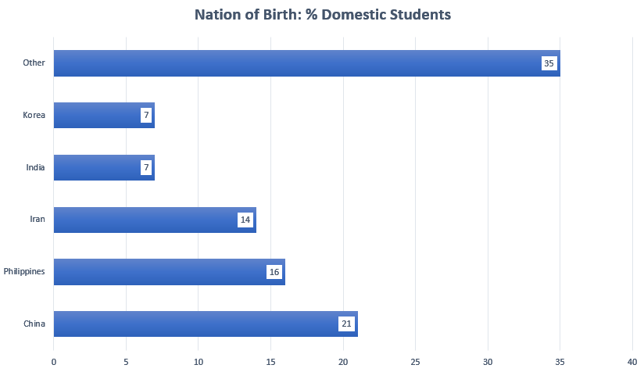
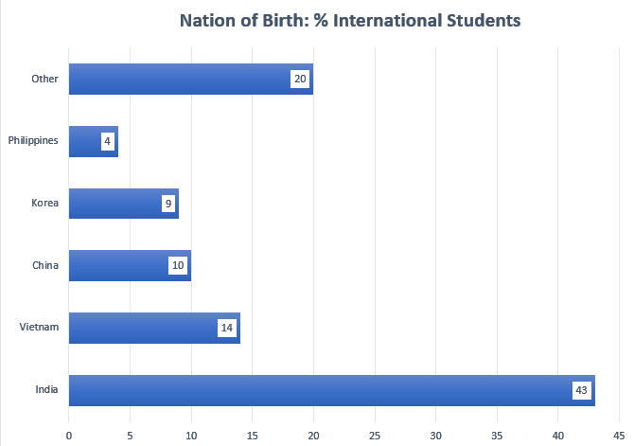

What It Means for How We Deliver Programming
The fact that so many countries are represented indicates the importance of creating learning experiences that work across multiple cultures. As Montgomery (2011) points out, intercultural educational spaces do not consist of binary ‘domestic’ vs ‘international’ groups but are instead “a complex site of struggle, tension and conflict” (ibid., p. 59), and that, properly mediated, this can be a useful and transformative learning space for all students.
Whereas it is known that most our international students come from India (43%), the weighting towards Punjabi-speaking vs Hindi/Gujarati speaking areas stands out. I can confirm this anecdotally by the number of young Sikh men and women I see at the Downtown Campus. The data show that over 11% of students speak Punjabi while fewer than 4% speak Hindi or Gujarati. We need to be looking at the specific cultural requirements of students from the Punjab rather than regarding our Indian students as a cultural monolith.
Another interesting finding is that while Iran is the country of origin of over 6% of students, Iranians represent less that 4% of international students – our Iranian students are mostly domestic students. Does this mean that we do not need to be as aware of their cultural needs? No, but it may indicate that they have more familiarity with the cultural expectations of the dominant group (Anglo-Canadians). The same applies to students from China, where again the majority are domestic students. When creating culturally sensitive programming for these students, the data suggest that we should be more concerned with specific cultural needs, rather than needs arising from studying away from home, since most of these students were living in Canada prior to becoming students at VCC.
Lastly, while understanding the linguistic diversity of the student population is useful, it is important to remember that linguistic diversity is not a perfect indicator of cultural diversity. We need to strive to meet the needs of a linguistically diverse student body (for example through captioning educational video and making sure our course materials are free from idiomatic English). But we also need to better understand the diverse cultural needs of the students, and this data only goes a short way to helping us achieve that goal. And we need to see the diversity of our student body not as a challenge to be overcome, but as a unique opportunity to design and co-design learning with and for our students that will prepare all our graduates for life in a globalized world.

References
Montgomery, C. (2011). Chapter 4. Developing Perceptions of Interculturality: A Troublesome Space? In B. Preisler, I. Klitgård & A. Fabricius (Ed.), Language and Learning in the International University: From English Uniformity to Diversity and Hybridity (pp. 59-75). Bristol, Blue Ridge Summit: Multilingual Matters. https://doi.org/10.21832/9781847694157-007
Statistics Canada. 2023. (table). Census Profile. 2021 Census of Population. Statistics Canada Catalogue no. 98-316-X2021001. Ottawa. Released March 29, 2023. https://www12.statcan.gc.ca/census-recensement/2021/dp-pd/prof/index.cfm?Lang=E (accessed June 11, 2023).
Vancouver Community College. 2021. Fast facts [infographic]. https://www.vcc.ca/media/vancouver-community-college/content-assets/documents/governance/board-of-governors/fast-facts.pdf

Appendix 1 Data Sources
The following data sources were consulted:
- VCC Annual Student Survey 2022
- VCC Student Profiles 2020-21
- VCC Fast Facts
- Statistics Canada 2021 Census data for Vancouver, Burnaby, Richmond, and Surrey – Mother Tongue of respondents

